Chapter 2 Section 1: Organisms and Their Relationships
Level 1 (TEKS: 10C, 11B, 12A)
Choose ONE of the following to complete:
- Book work
- Vocabulary Foldable: use the following terms (abiotic factor, biological community, biome, biosphere, biotic factor, commensalism, ecology, ecosystem, habitat, mutualism, niche, parasitism, population, predation, symbiosis)
- Flash cards: use the following terms (abiotic factor, biological community, biome, biosphere, biotic factor, commensalism, ecology, ecosystem, habitat, mutualism, niche, parasitism, population, predation, symbiosis)

Chapter 2 Section 1: Organisms and Their Relationships
Level 1 (TEKS: 10C, 11B, 12A)
Choose ONE of the following to complete:
- Book work
- Vocabulary Foldable: use the following terms (abiotic factor, biological community, biome, biosphere, biotic factor, commensalism, ecology, ecosystem, habitat, mutualism, niche, parasitism, population, predation, symbiosis)
- Flash cards: use the following terms (abiotic factor, biological community, biome, biosphere, biotic factor, commensalism, ecology, ecosystem, habitat, mutualism, niche, parasitism, population, predation, symbiosis)

Chapter 2 Section 1: Organisms and Their Relationships
Level 2 (TEKS: 10C, 11B, 12A)
Choose ONE of the following to complete:
- Book work
- Find a picture of an ecosystem and explain in a paragraph:
  - Two organisms occupying the same niche
  - Examples of mutualism, commensalism, parasitism, competition, predation
- Create a concept map: using abiotic factor, biological community, biome, biosphere, biotic factor, commensalism, ecology, ecosystem, habitat, mutualism, niche, parasitism, population, predation, symbiosis
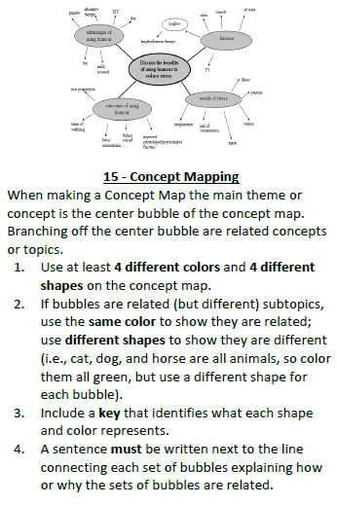

Chapter 2 Section 1: Organisms and Their Relationships
Level 3 (TEKS: 10C, 11B, 12A)
Choose ONE of the following to complete:
- Book work
- Create a cartoon about symbiotic relationships (all 5 types)
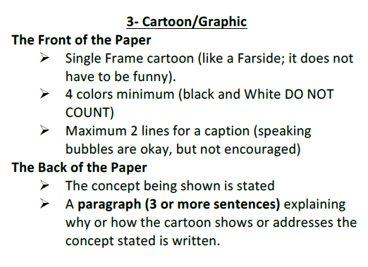
- Create a rap or song about symbiotic relationships (all 5 types)
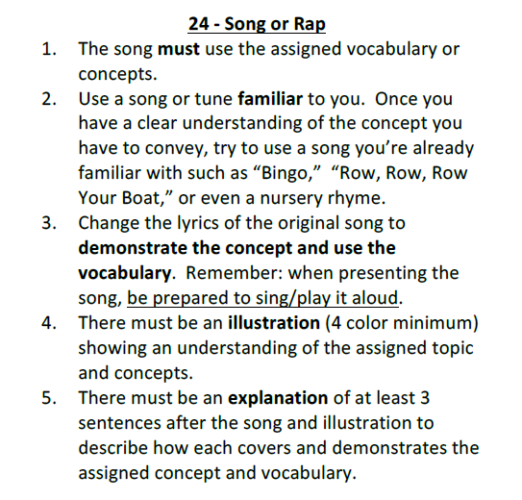

Chapter 2 Section 2: Flow of Energy in an Ecosystem
Level 1 (TEKS: 12C)
Choose ONE of the following to complete:
- Book work
- Vocabulary Foldable: use the following terms (autotroph, biomass, carnivore, decomposer, detritivore, food chain, food web, herbivore, heterotroph, omnivore, trophic level)
- Flash cards: use the following terms (autotroph, biomass, carnivore, decomposer, detritivore, food chain, food web, herbivore, heterotroph, omnivore, trophic level)

Chapter 2 Section 2: Flow of Energy in an Ecosystem
Level 1 (TEKS: 12C)
Choose ONE of the following to complete:
- Book work
- Vocabulary Foldable: use the following terms (autotroph, biomass, carnivore, decomposer, detritivore, food chain, food web, herbivore, heterotroph, omnivore, trophic level)
- Flash cards: use the following terms (autotroph, biomass, carnivore, decomposer, detritivore, food chain, food web, herbivore, heterotroph, omnivore, trophic level)

Chapter 2 Section 2: Flow of Energy in an Ecosystem
Level 2 (TEKS: 12C)
Choose ONE of the following to complete:
- Book work
- Create a food web for a particular habitat
  - Name all the organisms according to their grouping: autotroph or heterotroph
  - Identify their trophic level: producer, primary consumer, secondary consumer, tertiary consumer…
  - In a short statement, explain how much energy is used by the organisms and how much is passed on to the next trophic level.
- Create a concept map: using autotroph, biomass, carnivore, decomposer, detritivore, food chain, food web, herbivore, heterotroph, omnivore, trophic level
Chapter 2 Section 2: Flow of Energy in an Ecosystem
Level 3 (TEKS: 12C)
Choose ONE of the following to complete:
- Book work
- Create a cartoon about food chains, food webs, and energy pyramids
- Create an album cover about food chains, food webs, and energy pyramids.
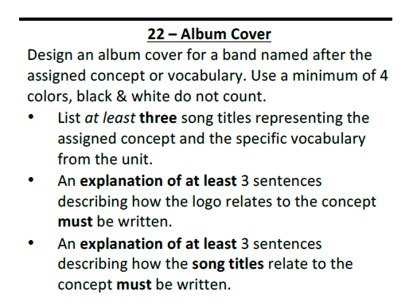

Chapter 2 Section 3: Cycling of Matter
Level 1 (TEKS: 12E)
Choose ONE of the following to complete:
- Book work
- Vocabulary Foldable: use the following terms (cycle, matter, nutrient, biogeochemical cycle, nitrogen fixation, denitrification)
- Flash cards: use the following terms (cycle, matter, nutrient, biogeochemical cycle, nitrogen fixation, denitrification)

Chapter 2 Section 3: Cycling of Matter
Level 1 (TEKS: 12E)
Choose ONE of the following to complete:
- Book work
- Vocabulary Foldable: use the following terms (cycle, matter, nutrient, biogeochemical cycle, nitrogen fixation, denitrification)
- Flash cards: use the following terms (cycle, matter, nutrient, biogeochemical cycle, nitrogen fixation, denitrification)

Chapter 2 Section 3: Cycling of Matter
Level 2 (TEKS: 12E)
Choose ONE of the following to complete:
- Book work
- In a foldable, compare and contrast the following: water cycle, carbon cycle, nitrogen cycle, phosphorus cycle (include pictures of each)
- Create a concept map: using cycle, matter, nutrient, biogeochemical cycle, nitrogen fixation, denitrification, water cycle, carbon cycle, nitrogen cycle, phosphorus cycle

Chapter 2 Section 3: Cycling of Matter
Level 3 (TEKS: 12E)
Choose ONE of the following to complete:
- Book work
- Create a t-shirt design about the biogeochemical cycles
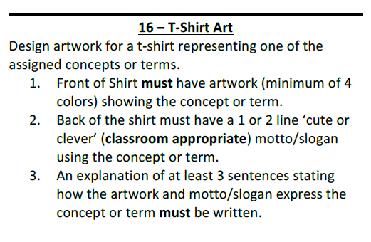
- Create an album cover about biogeochemical cycles

Chapter 3 Section 1: Community Ecology
Level 1 (TEKS: 11D, 12B)
Choose ONE of the following to complete:
- Book work
- Vocabulary Foldable: use the following terms (abiotic factor, climax community, community, ecological succession, limiting factor, primary succession, secondary succession, tolerance)
- Flash cards: use the following terms (abiotic factor, climax community, community, ecological succession, limiting factor, primary succession, secondary succession, tolerance)

Chapter 3 Section 1: Community Ecology
Level 1 (TEKS: 11D, 12B)
Choose ONE of the following to complete:
- Book work
- Vocabulary Foldable: use the following terms (abiotic factor, climax community, community, ecological succession, limiting factor, primary succession, secondary succession, tolerance)
- Flash cards: use the following terms (abiotic factor, climax community, community, ecological succession, limiting factor, primary succession, secondary succession, tolerance)

Chapter 3 Section 1: Community Ecology
Level 2 (TEKS: 11D, 12B)
Choose ONE of the following to complete:
- Book work
- Create a mural (on a sheet of paper) showing primary and secondary succession and the changes over time to ecosystem and species. Also, create an acronym for remembering primary from secondary succession.
- Complete 2 foldables (1-primary succession, 2-secondary succession). Describe how they work, showing change over time, and how populations and species diversity. A t-shirt design on succession, highlighting both types. Finally, create an acronym for remembering primary from secondary succession.

Chapter 3 Section 1: Community Ecology
Level 2 (TEKS: 11D, 12B)
Choose ONE of the following to complete:
- Book work
- Create a mural (on a sheet of paper) showing primary and secondary succession and the changes over time to ecosystem and species. Also, create an acronym for remembering primary from secondary succession.
- Complete 2 foldables (1-primary succession, 2-secondary succession). Describe how they work, showing change over time, and how populations and species diversity. A t-shirt design on succession, highlighting both types. Finally, create an acronym for remembering primary from secondary succession.

Chapter 3 Section 1: Community Ecology
Level 3 (TEKS: 11D, 12B)
Choose ONE of the following to complete:
- Book work
- Create a scrapbook (similar to a baby book) for succession as it grows into a climax community and then transforms again after a disaster to regrows into a climax community (include limiting factors).
- Create a rap or song about ecological succession as it grows into a climax community and then transforms again after a disaster to regrows into a climax community (include limiting factors).

Chapter 4 Section 1: Population Dynamics
Level 1 (TEKS: 12D, 12F)
Choose ONE of the following to complete:
- Book work
- Vocabulary Foldable: use the following terms (population, population density, dispersion, density-independent factor, density-dependent factor, emigration, population growth rate, immigration, carrying capacity)
- Flash cards: use the following terms (population, population density, dispersion, density-independent factor, density-dependent factor, emigration, population growth rate, immigration, carrying capacity)

Chapter 4 Section 1: Population Dynamics
Level 1 (TEKS: 12D, 12F)
Choose ONE of the following to complete:
- Book work
- Vocabulary Foldable: use the following terms (population, population density, dispersion, density-independent factor, density-dependent factor, emigration, population growth rate, immigration, carrying capacity)
- Flash cards: use the following terms (population, population density, dispersion, density-independent factor, density-dependent factor, emigration, population growth rate, immigration, carrying capacity)

Chapter 4 Section 1: Population Dynamics
Level 2 (TEKS: 12D, 12F)
Choose ONE of the following to complete:
- Book work
- Create a poem describing how environmental changes can impact an ecosystem stability. Complete an abstract (from a news article) on environmental changes and impact on stability on the RGV. Additionally in a triple Venn diagram, compare and contrast spatial distribution, population density, and population growth rate.
- Design a magazine ad showing how environmental changes can impact an ecosystem stability. Complete an abstract (from a news article) on environmental changes and impact on stability on the RGV. Additionally in a triple Venn diagram, compare and contrast spatial distribution, population density, and population growth rate.
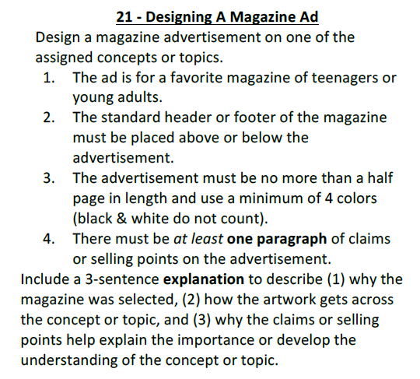

Chapter 4 Section 1: Population Dynamics
Level 3 (TEKS: 12D, 12F)
Choose ONE of the following to complete:
- Book work
- Write a newspaper article paragraph on how environmental change can impact an ecosystem stability: include carrying capacity, emigration, immigration, dispersion, population density, population growth rate
- Create a cartoon focused on how environmental change can impact an ecosystem stability: include carrying capacity, emigration, immigration, dispersion, population density, population growth rate

